Національний технічний університет України

«Київський політехнічний інститут ім. Ігоря Сікорського»

Кафедра цифрових технологій в енергетиці

ЗВІТ   
з виконання лабораторної роботи №3  
з дисципліни «Декларативне програмування графічних інтерфейсів»

«Творче завдання з розробити застосунку WPF»

Варіант 21

Виконав: студент групи ТР-12 Руденко В.І

Перевірив: доцент, к.ф.-м.н.  
Тарнавський Ю.А.

Код:

XAML код:

<Window x:Class="Lab3.MainWindow"

xmlns="http://schemas.microsoft.com/winfx/2006/xaml/presentation"

xmlns:x="http://schemas.microsoft.com/winfx/2006/xaml"

xmlns:d="http://schemas.microsoft.com/expression/blend/2008"

xmlns:mc="http://schemas.openxmlformats.org/markup-compatibility/2006"

xmlns:local="clr-namespace:Lab3"

mc:Ignorable="d"

Title="MainWindow" Height="450" Width="367">

<Window.Resources>

<Style TargetType="Button">

<Setter Property="FontSize" Value="30" />

<Setter Property="Foreground" Value="Black"/>

<Setter Property="FontWeight" Value="Bold"/>

</Style>

<LinearGradientBrush x:Key="LinearPanelBrush" StartPoint="0,0" EndPoint="0,1">

<GradientStop Color="Blue" Offset="0"/>

<GradientStop Color="Yellow" Offset="1"/>

</LinearGradientBrush>

<Style TargetType="Label">

<Setter Property="Background" Value="White"/>

<Setter Property="BorderBrush" Value="White"/>

<Setter Property="Margin" Value="5"/>

</Style>

<Style TargetType="Button" x:Key="DefaultBinderStyle">

<Setter Property="FontSize" Value="30" />

<Setter Property="Foreground" Value="Black"/>

<Setter Property="FontWeight" Value="Bold"/>

</Style>

<Style TargetType="Button" x:Key="BorderButtonStyle">

<Setter Property="BorderThickness" Value="2"/>

<Setter Property="BorderBrush" Value="Black"/>

<Setter Property="FontWeight" Value="Bold"/>

<Setter Property="FontSize" Value="30" />

<Setter Property="Foreground" Value="Black"/>

<Setter Property="FontWeight" Value="Bold"/>

</Style>

</Window.Resources>

<Grid>

<Grid.RowDefinitions>

<RowDefinition Height="*"/>

<RowDefinition Height="4*"/>

</Grid.RowDefinitions>

<Grid Grid.Row="0" Background ="{StaticResource LinearPanelBrush}">

<Label x:Name="MainOutput" HorizontalContentAlignment="Right" VerticalContentAlignment="Center" Grid.Row="0" Margin="5" Content=" 0 " Focusable="False"/>

</Grid>

<Grid Grid.Row="1" Name="NumpadDefinition">

<Grid.RowDefinitions>

<RowDefinition x:Name="ZeroRow"/>

<RowDefinition x:Name="FirstRow"/>

<RowDefinition x:Name="SecondRow"/>

<RowDefinition x:Name="LastRow"/>

</Grid.RowDefinitions>

<Grid.ColumnDefinitions>

<ColumnDefinition x:Name="ZeroColumn"/>

<ColumnDefinition x:Name="FirstColumn"/>

<ColumnDefinition x:Name="SecondColumn"/>

<ColumnDefinition x:Name="LastColumn"/>

</Grid.ColumnDefinitions>

<Button x:Name="SevenNumber" Content="7" Grid.Row="0" Click="Button_Click"/>

<Button x:Name="FourNumber" Content="4" Grid.Row="1" Click="Button_Click"/>

<Button x:Name="OneNumber" Content="1" Grid.Row="2" Click="Button_Click"/>

<Button x:Name="C" Grid.Row="7" Content="C" Click="Reset"/>

<Button x:Name="EightNumber" Content="8" Grid.Column="1" Grid.Row="0" Click="Button_Click"/>

<Button x:Name="FiveNumber" Content="5" Grid.Column="1" Grid.Row="1" Click="Button_Click"/>

<Button x:Name="TwoNumber" Grid.Column="1" Grid.Row="2" Content="2" Click="Button_Click"/>

<Button x:Name="ZeroNumber" Content="0" Grid.Column="1" Grid.Row="7" Click="Button_Click"/>

<Button x:Name="NineNumber" Content="9" Grid.Column="2" Grid.Row="0" Click="Button_Click"/>

<Button x:Name="SixNumber" Content="6" Grid.Column="2" Grid.Row="1" Click="Button_Click"/>

<Button x:Name="ThreeNumber" Grid.Column="2" Grid.Row="2" Content="3" Click="Button_Click"/>

<Button x:Name="equal" Content="=" Grid.Column="2" Grid.Row="7" Click="Reset"/>

</Grid>

</Grid>

</Window>

CS код:

using DocumentFormat.OpenXml.Vml.Spreadsheet;

using System;

using System.Collections.Generic;

using System.Linq;

using System.Text;

using System.Threading.Tasks;

using System.Windows;

using System.Windows.Controls;

using System.Windows.Data;

using System.Windows.Documents;

using System.Windows.Input;

using System.Windows.Media;

using System.Windows.Media.Animation;

using System.Windows.Media.Imaging;

using System.Windows.Navigation;

using System.Windows.Shapes;

namespace Lab3

{

/// <summary>

/// Interaction logic for MainWindow.xaml

/// </summary>

public partial class MainWindow : Window

{

enum CurrentState

{

Default,

Plus,

Minus,

Multiply,

Devine

};

CurrentState currentState = CurrentState.Default;

double CurrentValue = 0;

Button CurrentOperation;

public MainWindow()

{

InitializeComponent();

CreateAdditionsButtons();

ResetValue();

MainOutput.Content = "0";

}

private void ResetValue()

{

currentState = CurrentState.Default;

CurrentValue = 0;

}

private void CreateAdditionsButtons()

{

Button PlusButton = new Button();

PlusButton.Content = "+";

Grid.SetRow(PlusButton, 0);

Grid.SetColumn(PlusButton, 3);

NumpadDefinition.Children.Add(PlusButton);

PlusButton.Click += ChoosedOperation;

Button MinusButton = new Button();

MinusButton.Content = "-";

Grid.SetRow(MinusButton, 1);

Grid.SetColumn(MinusButton, 3);

NumpadDefinition.Children.Add(MinusButton);

MinusButton.Click += ChoosedOperation;

Button MultiplyButton = new Button();

MultiplyButton.Content = "*";

Grid.SetRow(MultiplyButton, 2);

Grid.SetColumn(MultiplyButton, 3);

NumpadDefinition.Children.Add(MultiplyButton);

MultiplyButton.Click += ChoosedOperation;

Button DivideButton = new Button();

DivideButton.Content = "/";

Grid.SetRow(DivideButton, 3);

Grid.SetColumn(DivideButton, 3);

NumpadDefinition.Children.Add(DivideButton);

DivideButton.Click += ChoosedOperation;

}

private void ChoosedOperation(object sender, RoutedEventArgs e)

{

var button = sender as Button;

if (button != null)

{

switch (button.Content.ToString())

{

case "+":

currentState = CurrentState.Plus;

break;

case "-":

currentState = CurrentState.Minus;

break;

case "*":

currentState = CurrentState.Multiply;

break;

case "/":

currentState = CurrentState.Devine;

break;

default:

currentState = CurrentState.Default;

break;

}

if (CurrentOperation == null)

{

CurrentValue = Double.Parse(MainOutput.Content.ToString());

}

else

{

CurrentOperation.Style = (Style)FindResource("DefaultBinderStyle");

}

MainOutput.Content = button.Content.ToString();

button.Style = (Style)FindResource("BorderButtonStyle");

CurrentOperation = button;

}

}

private void Button_Click(object sender, RoutedEventArgs e)

{

var button = sender as Button;

if (button != null)

{

MainOutput.Content = button.Content;

switch (currentState)

{

case CurrentState.Plus:

CurrentValue += Double.Parse(MainOutput.Content.ToString());

MainOutput.Content = CurrentValue.ToString();

break;

case CurrentState.Minus:

CurrentValue -= Double.Parse(MainOutput.Content.ToString());

MainOutput.Content = CurrentValue.ToString();

break;

case CurrentState.Multiply:

CurrentValue *= Double.Parse(MainOutput.Content.ToString());

MainOutput.Content = CurrentValue.ToString();

break;

case CurrentState.Devine:

CurrentValue /= Double.Parse(MainOutput.Content.ToString());

MainOutput.Content = CurrentValue.ToString();

break;

case CurrentState.Default:

MainOutput.Content = button.Content;

break;

}

currentState = CurrentState.Default;

if (CurrentOperation != null)

{

CurrentOperation.Style = (Style)FindResource("DefaultBinderStyle");

CurrentOperation = null;

}

}

}

private void Reset(object sender, RoutedEventArgs e)

{

var button = sender as Button;

if (button.Content.ToString() == "=")

{

MainOutput.Content = CurrentValue.ToString();

}

else

{

MainOutput.Content = "0";

}

ResetValue();

}

}

}

Скріншот виконання:

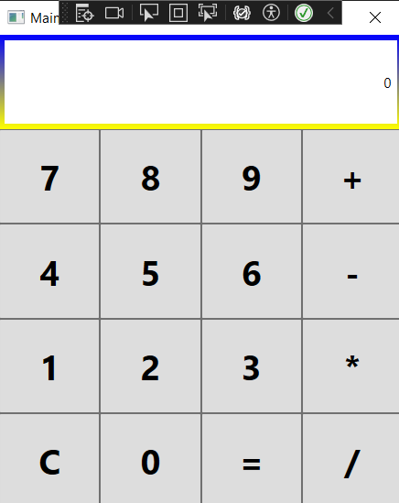

Table 1 Інтерфейс Додатку

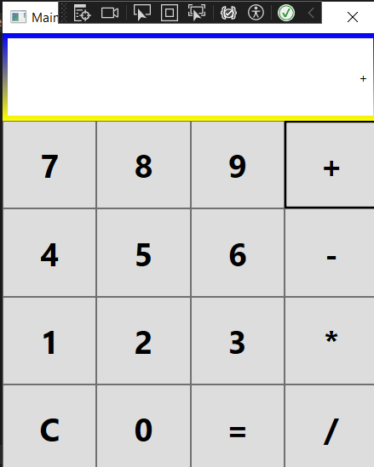

Table 2 Обрання Завдання Розрахунку

**Посилання на GIThub репозиторій -****https://github.com/Nepji/GI_Lab_1/tree/lab3**